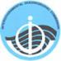
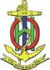
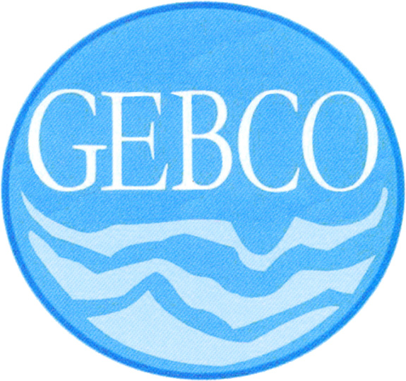

INTERGOVERNMENTAL OCEANOGRAPHIC
COMMISSION

COMMISSION OCEANOGRAPHIQUE
INTERGOUVERNEMENTALE

PARIS

INTERNATIONAL HYDROGRAPHIC
ORGANIZATION

ORGANISATION HYDROGRAPHIQUE
INTERNATIONALE

MONACO

C E N T E N A R Y 1 9 0 3 – 2 0 0 3

Call for Papers
Seventh Annual
GEBCO Bathymetric Science Day
Principality of Monaco, 02 October 2012
Hosted by the Directing Committee of the International Hydrographic Bureau
At Salle du Ponant, 2 ave d'Ostende, 98000 Monaco

The IHO/IOC Committee for the General Bathymetric Charts of the Oceans (GEBCO, www.gebco.net) is an international body undertaking global bathymetric mapping and naming of undersea features. The 2012 GEBCO meetings will take place 1 – 5 October 2012 at the International Hydrographic Office (IHO) and Salle du Ponant in the Principality of Monaco. The “GEBCO Bathymetric Science Day” is the meeting day for science and technology presentations. It will be held Tuesday 2 October at Salle du Ponant. Oral presentations and posters on topics related to ocean mapping and its applications are welcome. Focus areas include, but are not limited to:

- Technical aspects of merging topography, bathymetry, and shoreline data in coastal zones
- Compilation and fusion of heterogeneous data, gridding, and modeling uncertainty
- Use of Google Ocean in research, education, and outreach.
- Data management and exchange, standards, protocols, schema, services
- Applications and application-driven mapping
- History and reviews of bathymetric science and regional bathymetric compilations

Also, the IHO/IAG Advisory Board on the Law of the Sea (ABLOS) will meet concurrently with the GEBCO meetings. ABLOS attendees are especially invited to contribute and attend Science Day.

Science Day is an excellent venue for exchanging ideas and growing new collaborations. Please come, share your knowledge, and join an international and cross-disciplinary team engaged in exciting and fundamental work. The ocean is big and there is room for everyone to contribute. Any contributor to Science Day may attend all meeting days of GEBCO’s Technical Sub-Committee on Ocean Mapping (TSCOM) and Sub-Committee on Regional Undersea Mapping (SCRUM) and the Wednesday 03 October meeting of ABLOS. All contributors are encouraged to publish their presentations through GEBCO’s website at www.gebco.net.

Those wishing to contribute a presentation should contact by email the GEBCO Bathymetric Science Day coordinator, Dr. Paul Elmore, (GEBCO_Science_Day@nrlssc.navy.mil), with a copy to the local coordinator, Anthony Pharaoh (anthony.pharaoh@iho.int) and GEBCO’s webmaster Pauline Weatherall (paw@bodc.ac.uk). Please include the anticipated Title of the contribution, the Authors and their Institutional Affiliations, and whether an oral or poster presentation is preferred. Oral presentations are encouraged to be at a general audience level, whereas more technical or detailed material is encouraged for poster presentations. Contributors will receive instructions for uploading presentations to GEBCO in advance of the meeting (presenters can leave their presentations off GEBCO’s website by indicating this preference by email).

