
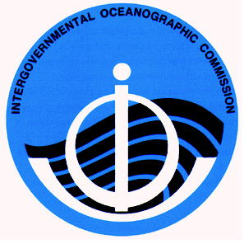
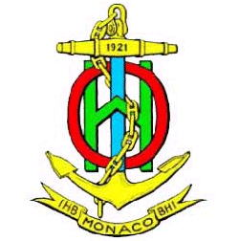
INTERGOVERNMENTAL OCEANOGRAPHIC
COMMISSION
COMMISSION OCEANOGRAPHIQUE
INTERGOUVERNEMENTALE
PARIS
INTERNATIONAL HYDROGRAPHIC
ORGANIZATION
ORGANISATION HYDROGRAPHIQUE
INTERNATIONALE
MONACO

C E N T E N A R Y 1 9 0 3 – 2 0 0 3

Call for Papers
Fourth Annual
GEBCO Bathymetric Science Day
Brest, France
29 September 2009
Hosted by the French Hydrographic and Oceanographic Service
At Oceanopolis, Brest

The IHO/IOC Committee for the General Bathymetric Charts of the Oceans (GEBCO, www.gebco.net) is the international body responsible for global bathymetric mapping and the naming of undersea features. GEBCO’s Technical Sub-Committee on Ocean Mapping (TSCOM) conducts research, reviews technical challenges and opportunities, maintains and improves the GEBCO Digital Atlas and global bathymetric grid, and advises GEBCO on scientific and technical aspects of its mission. The 25th meeting of the TSCOM will take place 28 – 30 September 2009 at the offices of the French Hydrographic and Oceanographic Service, SHOM in Brest. Oral and poster presentations will be featured throughout the three meeting days. In particular, GEBCO’s Fourth Annual “Bathymetric Science Day” will be held on 29 September. Contributed papers on any topic related to ocean mapping and its applications are welcome. Focus areas include, but are not limited to:

- Uses of Google Ocean in research, education and outreach.
- Data management and exchange (web-enabled and geospatial-enabled services, metadata standards, database schema, data processing and validation, etc.).
- Merging topography, bathymetry, and shoreline data in the coastal zone (seamless models, vertical datum issues, etc.).
- Compilation and fusion of heterogeneous data (single and multi-beam, points, grids, shorelines, etc.).
- Applications and application-driven mapping (e.g., bathymetric needs of fisheries and habitat sciences, hydrodynamic models, etc.).
- Interpolation and gap-filling schemes for incompletely surveyed areas.
- Modeling bathymetric uncertainty.

All contributions will be featured on the agenda, in the minutes, and on www.gebco.net. TSCOM is an excellent venue for exchanging ideas and growing new collaborations. Please come, share your knowledge, and join an international and cross-disciplinary team engaged in exciting and fundamental work. The ocean is big and there is room for everyone to contribute. The TSCOM meeting is open, and any contributor to Science Day may attend all three days of TSCOM.

Those wishing to contribute a presentation should contact the TSCOM Chair and local coordinating committee by email to both walter.hf.smith@noaa.gov and also marie-francoise.lalancette@shom.fr, preferably by 25 August 2009. Please include the anticipated title of the contribution, the authors and their institutional affiliations, and whether an oral or poster presentation is preferred. It is anticipated that, at some time closer to the meeting, a web site will be established to which contributors shall upload presentations and abstracts for the meeting program and minutes.

