
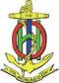
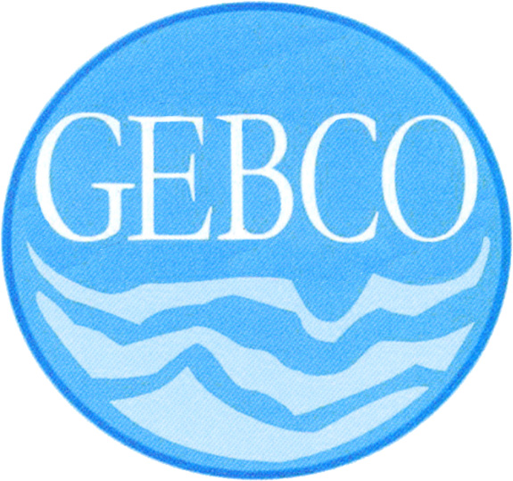

INTERGOVERNMENTAL OCEANOGRAPHIC
COMMISSION

COMMISSION OCEANOGRAPHIQUE
INTERGOUVERNEMENTALE

PARIS

INTERNATIONAL HYDROGRAPHIC
ORGANIZATION

ORGANISATION HYDROGRAPHIQUE
INTERNATIONALE

MONACO

C E N T E N A R Y 1 9 0 3 – 2 0 0 3

Call for Papers

Sixth Annual
GEBCO Bathymetric Science Day

La Jolla, California, USA
4 October 2011
Hosted by the University of California Scripps Institution of Oceanography
At the Scripps Seaside Forum

The IHO/IOC Committee for the General Bathymetric Charts of the Oceans (GEBCO, www.gebco.net) is the international body responsible for global bathymetric mapping and the naming of undersea features. The 2011 GEBCO meetings will take place 3 – 7 October 2011 at the Scripps Institution of Oceanography in La Jolla, California, USA. “Bathymetric Science Day” will be held on Tuesday 4 October, within GEBCO's Technical Sub-Committee on Ocean Mapping (TSCOM) meeting. Contributed papers on any topic related to ocean mapping and its applications are welcome. Focus areas include, but are not limited to:

- Merging topography, bathymetry, and shoreline data in the coastal zone
- Compilation and fusion of heterogeneous data, gridding, modeling uncertainty
- Use of Google Ocean in research, education, and outreach.
- Data management and exchange, standards, protocols, schema, services
- Applications and application-driven mapping
- History and reviews of bathymetric science.

All contributions will be published through www.gebco.net. TSCOM is an excellent venue for exchanging ideas and growing new collaborations. Please come, share your knowledge, and join an international and cross-disciplinary team engaged in exciting and fundamental work. The ocean is big and there is room for everyone to contribute. The TSCOM meeting is open, and any contributor to Science Day may attend all days of TSCOM.

Those wishing to contribute a presentation should contact by email the TSCOM Chair, Dr Walter Smith, (walter.hf.smith@noaa.gov) with a copy to the local coordinating committee Chair, Prof David Sandwell (dsandwell@ucsd.edu) and the GEBCO Permanent Secretary, David Clark (David.M.Clark@noaa.gov) preferably by 1 September 2011. Please include the anticipated Title of the contribution, the Authors and their Institutional Affiliations, and whether an oral or poster presentation is preferred. Contributors will receive instructions for uploading presentations to GEBCO in advance of the meeting.

