GEBCO Guidance for Transit Mapping

Draft v1.0 prepared by Dr. Vicki Ferrini & Jennifer Jencks, Sept 2025

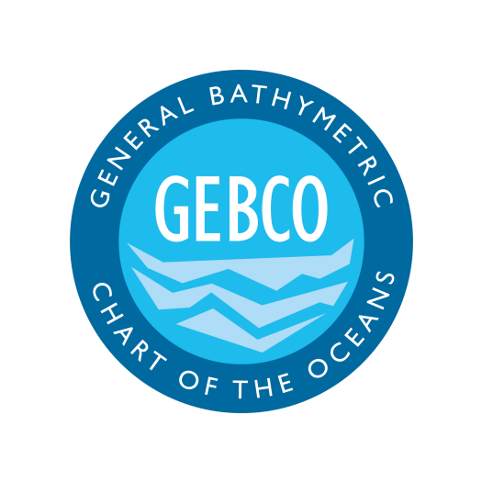

Introduction

I. Purpose and Scope

II. Target Audience

III. The Importance of Transit Mapping

IV. Document Structure

1. Data Contribution to National and Global Repositories

1.1 Repositories for Transit Mapping Data

1.2 Overview of Transit Data Flow

1.3 Institutional Roles and Responsibilities

1.4 Submitting Data

1.5 Accessing Transit Mapping Data

2. Transit Data Collection

2.1 Systems and Sensors

2.1.1 Multibeam Echo Sounders (MBES)

2.1.2 Positioning and Motion Sensors

2.1.3 Sound Speed Profiling

2.2 Sensor Configuration and Offsets

2.2.2 Angular Offsets (Patch Test Calibration)

2.3 Ancillary Data

2.4 Software and Data Management

2.4.1 Data Loggers and Acquisition Software

2.4.2 Onboard Data Storage and Redundancy

2.4.3 Data Transfer

2.5 Best Practices for Transit Mapping

3. Data and Metadata

3.1 Data vs. Metadata

3.2 Importance of Metadata

4. Data Quality Assessment

4.1 Data Consistency

4.2 Data Quality Assessment Reports

4.3.4 Summary

5 Enhancing the Value of Transit Mapping Through Planning

5.1 Institutional Policies to Support Transit Mapping

5.2 Capacity Building and Community Benefits

5.3 User Awareness and Liability

6. Additional Considerations

6.1 Open Access and Licensing

6.2 Operations in International Waters and EEZs

6.3 Supplemental Resources

7. Summary and Conclusions

8. References

# **Introduction**

## I. Purpose and Scope

The purpose of this document is to provide guidance to transit mapping stakeholders to help them plan, collect, and contribute bathymetric data collected during vessel transits in a format that is useful to the broadest possible audience. This document aims to optimize data collection and sharing, following recommendations promoted by the International Hydrographic Organization (IHO), the General Bathymetric Chart of the Ocean Technical SubCommittee for Ocean Mapping (TSCOM), and the Nippon Foundation-GEBCO Seabed 2030 Project initiative for gathering and contributing seafloor mapping data into public data repositories.

Unlike dedicated surveys or citizen science efforts (referred to as crowdsourced bathymetry), transit mapping focuses on systematically acquiring high-quality data during vessel passages between primary mission sites or ports. With the main aim being to maximize the return on vessel operations by collecting useful multibeam and ancillary data, this document does not prescribe a single technology or software. Instead, it provides general concepts about transit mapping acquisition, metadata necessary for data archiving and access, metadata recommended to enhance data usefulness and data quality considerations, to help vessel operators, data managers, and end users engage in transit mapping activities.

This document is not intended to provide definitive hydrographic survey standards or guidance towards the collection of bathymetry data; for these, the reader is referred to IHO C-13, IHO S-44 (6th edition) and IHO B-12 (3rd edition). Rather, it provides practical guidance on how to optimize the acquisition, processing, and use of opportunistic multibeam data collected during transits, ensuring its long-term value for science, navigation, and global mapping efforts.

## II. Target Audience

This document seeks to inform and guide all stakeholders involved in transit mapping, including:

* **Research vessel operators, planners and technical staff** responsible for configuring and maintaining mapping systems during transits.
* **Data managers and repositories** responsible for archiving and integrating transit mapping data.
* **Funding agencies and program managers** interested in maximizing the return on investment of vessel time by supporting systematic data acquisition during transits.

End users of transit mapping data may also find this document informative, as it outlines how data are collected, processed, and shared.

## III. The Importance of Transit Mapping

Transit mapping represents one of the most cost-effective opportunities to accelerate progress toward a complete map of the ocean. Unlike dedicated surveys, transit mapping requires no additional ship time or fuel—it simply makes use of vessel passages that already occur. By encouraging and authorizing routine acquisition and sharing of these data, decision makers can substantially increase the return on investment in vessel operations while contributing to global priorities.

Supporting transit mapping is not only a matter of efficiency; it is also a matter of leadership. Nations, agencies, and institutions that adopt transit mapping practices demonstrate their commitment to open science, international collaboration, and the responsible stewardship of the ocean. Transit mapping data directly inform navigation safety, climate and hazard research, resource management, and sustainable development. They also contribute to international initiatives such as Seabed 2030 and the UN Decade of Ocean Science, both of which rely on community participation to meet ambitious global goals.

Decision makers are uniquely positioned to make transit mapping routine by:

* Establishing policies and expectations that mapping systems remain active during transits whenever feasible.
* Ensuring resources are available to support proper data management and sharing.
* Recognizing and rewarding institutions and operators who contribute to the global mapping effort.

The choice to support transit mapping is a low-cost, high-impact action that delivers scientific, societal, and diplomatic benefits. By enabling even modest changes to operational practice, decision makers can ensure that otherwise idle transit time is transformed into valuable knowledge for the world.

Transit mapping data are acquired by research and exploration vessels equipped with multibeam echo sounders (MBES) and associated navigation and motion sensors. While such vessels are typically deployed for dedicated surveys, transit mapping ensures that time spent traveling between stations or ports is also used to collect scientifically and operationally valuable bathymetric data.

This practice has already been adopted by elements of the academic community, government initiatives, and, to a lesser extent, the private sector. These efforts have demonstrated clear benefits, including the efficient collection of high-quality data, contributions to navigation safety, and the advancement of international mapping initiatives. Despite these successes, participation remains limited, and significant opportunity exists to expand adoption across academic, government, and industry sectors. Broader engagement would accelerate progress toward global seafloor mapping while enhancing the return on investment in vessel operations.

## IV. Document Structure

This document addresses several topics related to transit mapping as described in the Table of Contents. Additional detail and further reading are provided via Annexes and external links. This guidance is intended to be a living document and will be updated in light of further experience and feedback from vessel operators, data managers, and data users.

# **1. Data Contribution to National and Global Repositories**

The primary goal of transit mapping is to increase data holdings in publicly accessible data repositories to further regional and global efforts toward creating and updating a global map of the seafloor.

This chapter details the process, guidance, recommendations and requirements for contributing transit mapping data to established repositories that preserve, curate, and distribute bathymetric data. These repositories ensure that data collected during vessel transits are discoverable and accessible, supporting international initiatives such as the Nippon Foundation-GEBCO Seabed 2030 Project and the General Bathymetric Chart of the Oceans (GEBCO) along with regional and national efforts.

## 1.1 Repositories for Transit Mapping Data

Open data archives are essential to ensuring that transit mapping data are preserved, discoverable, and accessible to the widest possible community of users. By contributing to trusted repositories, vessel operators and data managers can be confident that their data will not only be safeguarded, but also integrated into regional and global compilations that support science, navigation, and policy.

Importantly, transit mapping data do not need to be fully cleaned or rigorously quality controlled before being shared. Even minimally processed or raw data provide significant value. Shared openly, these data help to close gaps in regional and global bathymetric coverage, guide future surveys, and allow community members with diverse expertise to apply their own methods of processing and analysis. This distributed approach to data assessment is a strength of open science, enabling a wider range of applications and maximizing the return on every sounding collected. In the context of the sparse mapping coverage that exists today, every contribution—no matter how preliminary—moves the global community closer to the shared goal of a complete map of the seafloor.

Several repositories and archives play key roles in managing transit mapping data:

* **IHO Data Centre for Digital Bathymetry (**[**DCDB**](https://www.ncei.noaa.gov/iho-data-centre-digital-bathymetry)**):** Established by the IHO in 1990 and hosted by NOAA/NCEI, the DCDB stewards the global collection of open bathymetric data, including data collected during transits.
* **Community Data Systems:** National and institutional pipelines manage the archiving and distribution of mapping data. Examples include the [**Rolling Deck to Repository**](https://www.rvdata.us/) **(R2R)** for U.S. academic research vessels, and [**PANGAEA**](https://www.pangaea.de/) for European-led multidisciplinary data archiving.
* **Other Institutional and National Archives:** Many operators maintain their own repositories or contribute to regional or national data portals (e.g., [AusSeabed](https://www.ausseabed.gov.au/)), which in turn feed into global compilations.

Together, these repositories ensure that transit mapping data—whether raw or fully processed—are preserved, discoverable, and usable, creating lasting value for the global community. Operators are encouraged to share transit data as early as possible, even in raw form, with confidence that the data will be valuable to the mapping community and that even imperfect data contributes meaningfully to global goals.

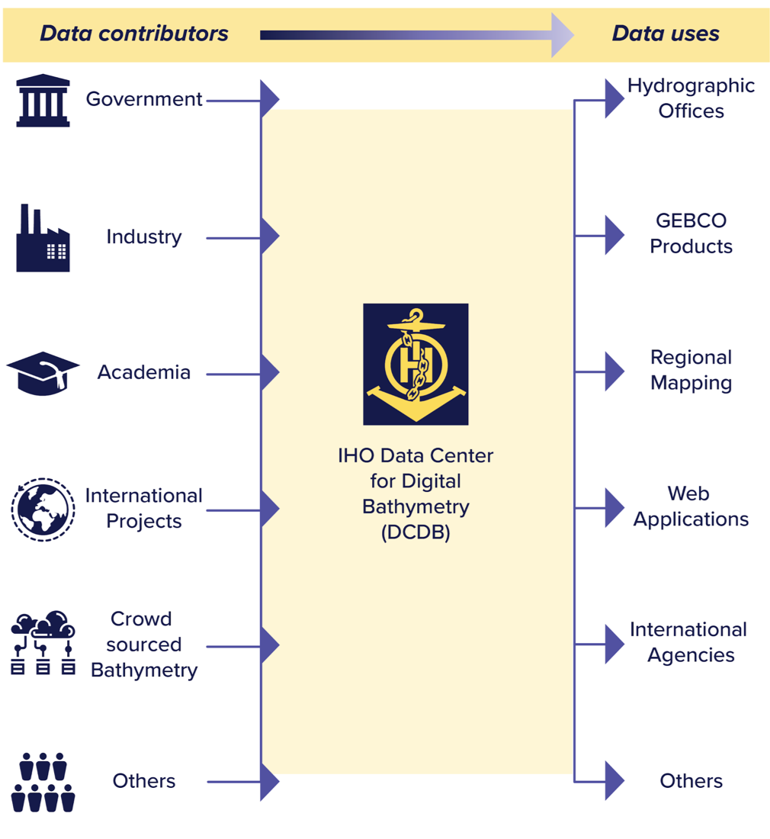

*Figure 1: Flow of data from contributors to the IHO DCDB to various users.*

## 1.2 Overview of Transit Data Flow

The flow of transit mapping data follows the same general framework as that for dedicated survey data, with established steps that ensure preservation, access, and long-term usability. What distinguishes transit mapping is that the handoff to repositories can occur much sooner after acquisition. Because there is no requirement for extensive quality control or post-processing before submission, data can be made available rapidly in their raw form. This accelerates discovery, reduces the risk of data loss, and allows the wider community of experts to apply their own methods for processing, evaluation, and integration.

The responsibility of the data acquirer effectively ends at the point of handoff. From there, data systems and professional stewards take on the work of ensuring preservation, metadata robustness, versioning, and provenance tracking—linking raw soundings to processed datasets and derived products. Once accessible, the data enter the broader ocean mapping ecosystem, where international experts analyze, refine, and apply them for a wide variety of uses.

Rapid handoff offers additional advantages. It minimizes bottlenecks for vessel operators, spreads the workload of processing and assessment across the broader community, and ensures that even preliminary data can be used to close mapping gaps or identify areas of interest for future surveys (Ferrini and Peters, 2022). By accelerating the pathway from acquisition to availability, transit mapping strengthens the efficiency and collective impact of the global ocean mapping enterprise.

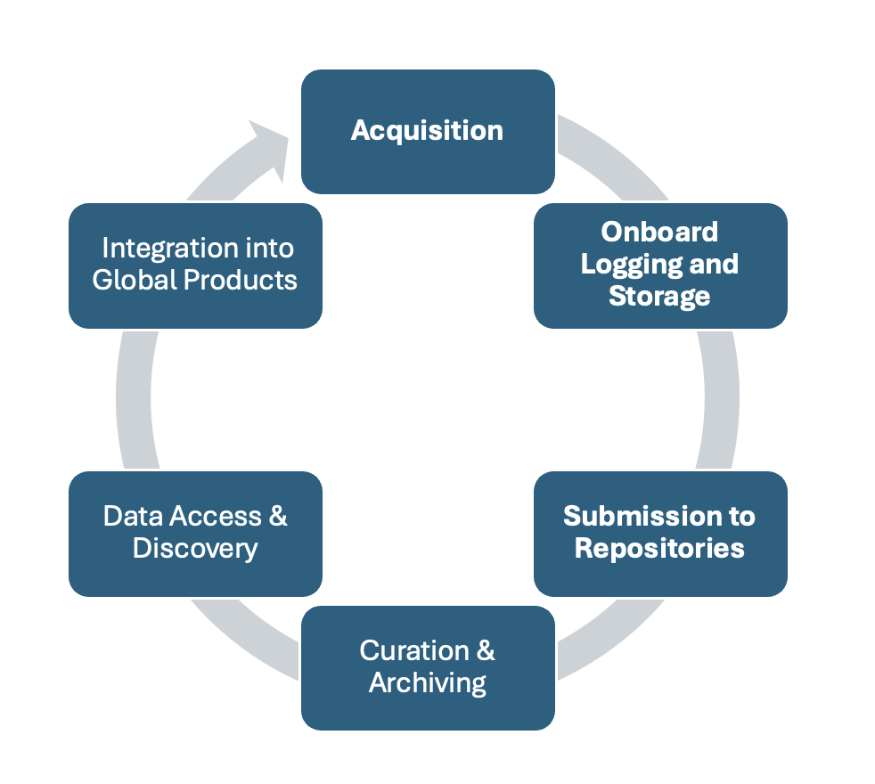

*Figure 2: Data life cycle for transit mapping data.*

The general workflow for transit mapping data can be summarized as follows:

* **Acquisition:** Multibeam systems continuously record depth, backscatter, and navigation data during vessel transits.
* **Onboard Logging and Storage:** Data are logged to shipboard servers and backed up for redundancy.
* **Submission to Repositories:** At the conclusion of a voyage, data packages (including metadata) are transferred to national or institutional repositories (e.g., IHO DCDB, R2R, PANGAEA).
* **Curation and Archiving:** Repositories review metadata, assign persistent identifiers (e.g., DOIs), and provide stewardship and long-term preservation of the data. Many repositories also conduct quality assessment reviews.
* **Data Access and Discovery:** Repositories provide open access to transit data and metadata, enabling a wide variety of uses across the global community.
* **Integration into Global Products:** Curated and processed datasets are incorporated into international compilations such as GEBCO. Processed data products generated by the wider community may also be made openly available through data platforms such as the [MGDS](https://www.marine-geo.org/) and PANGAEA.

This workflow reflects the coordinated nature of global ocean mapping: each participant—vessel operators, data repositories, and the broader expert community—plays a distinct but interconnected role in turning raw transit soundings into lasting contributions to science, navigation, and global knowledge of the seafloor.

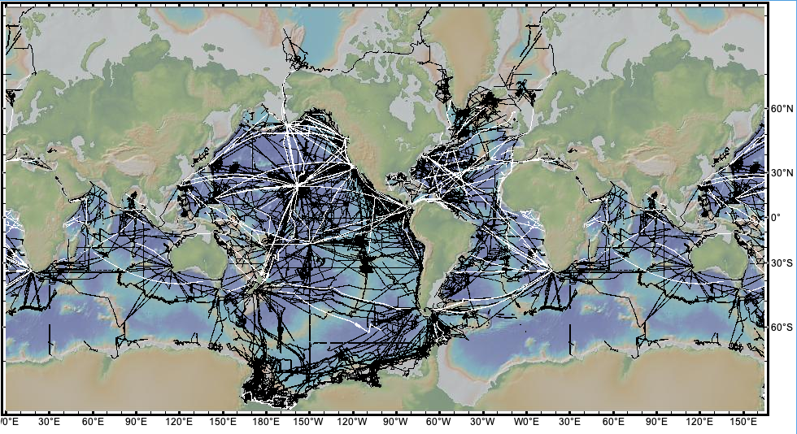*Figure 3: The geospatial extent of multibeam data sets included in GMRT version 4.4.0 (released Aug 2025). Black lines indicate expedition data, which often includes transit data acquired from port to the study site. White lines indicate transit data acquired when the entire leg from port to port was merely a vessel transit. These transit lines add significant data coverage to public data holdings, as well as national, regional and international data compilations.*

## 1.3 Institutional Roles and Responsibilities

Institutions and vessel operators play a critical role in enabling transit mapping by ensuring that data are collected and handed off for long-term preservation and use. Their primary responsibility is to operate mapping systems during transits and to optimize data collection within the practical limits of vessel operations. This includes ensuring that multibeam and navigation systems are active, and that complete datasets—such as raw sonar files, sound speed profiles, and navigation logs—are captured whenever feasible.

By prioritizing data collection and data submission, institutions and vessel operators ensure that valuable information is not lost and can be preserved, curated, and optimized by the broader community. This division of responsibilities—acquisition by operators, stewardship by repositories, and refinement by the expert community—reflects the collaborative model that underpins global ocean mapping.

The responsibility of vessel operators and institutions effectively ends with the handoff of these data. While some organizations may choose to conduct additional data stewardship, quality checks, or cleaning before submission, this is not a requirement. The essential contribution is the acquisition of data and the transfer of those data, along with the associated metadata, to appropriate repositories.

## 1.4 Submitting Data

Submitting transit mapping data to an appropriate repository is the essential step that ensures preservation, discoverability, and reuse by the global community. While submission processes vary by repository, the key requirements are broadly consistent:

* **Metadata Completeness:** Cruise or expedition identifiers, vessel information, sensor configurations, offsets, and acquisition details must be captured to ensure that data can be properly archived, discovered, and reused.
* **File Formats:** Standard formats are preferred. These include raw MBES files (e.g., *Simrad .all*, *Kongsberg .kmall*), processed swath data files, and raster grids such as NetCDF or GeoTIFF. Providing raw files alongside processed products is strongly encouraged, as they support versioning, reproducibility, and future reprocessing.
* **Licensing:** Transit mapping data are generally shared under open terms, most commonly Creative Commons Zero (CC0 1.0), ensuring that data can be freely reused without restriction.

Repositories such as the IHO Data Centre for Digital Bathymetry (DCDB), the Marine Geoscience Data System (MGDS), and PANGAEA provide detailed submission guidelines, and potential data providers should consult these resources directly for current instructions (see table). For the U.S. Academic Research Fleet, data handoff is managed automatically through the Rolling Deck to Repository (R2R) program, which serves as the designated pipeline for archiving and distributing vessel data.

By following repository-specific guidance and ensuring early, open submission of transit data, operators can be confident that their contributions will be preserved, discoverable, and useful to a broad spectrum of end users worldwide.

*Table 1: Data submission guidance by repository*

|  |  |
| --- | --- |
| **Repository** | **Submission Guide / Info** |
| **IHO Data Centre for Digital Bathymetry (DCDB)** | “Submitting Marine Geophysical Data” page on NOAA/NCEI & IHO DCDB. Describes how to prepare multibeam bathymetry, sounder data, navigation logs, etc., and what file/format/metadata requirements exist. ([NCEI](https://www.ncei.noaa.gov/iho-data-centre-digital-bathymetry/submitting-marine-geophysical-data?utm_source=chatgpt.com)) |
| **Marine Geoscience Data System (MGDS / Marine-Geo)** | “How to Contribute Data” page: accepts raw sensor data and derived products; data registration form; documents and images can help usability; guidance for format and metadata. ([Marine Geo](https://www.marine-geo.org/submit/?utm_source=chatgpt.com)) |
| **PANGAEA** | Authors' Guides: metadata and data formatting requirements, file-type and format templates, editorial review process, licensing, etc. ([Pangaea](https://www.pangaea.de/submit/?utm_source=chatgpt.com)) |

## 1.5 Accessing Transit Mapping Data

Transit mapping data are made openly accessible through multiple pathways, ensuring that they can be discovered and used by the widest possible range of stakeholders:

* [**IHO DCDB Map Viewer**](https://www.ncei.noaa.gov/maps/iho_dcdb/)**:** The IHO Data Centre for Digital Bathymetry (DCDB), hosted by NOAA/NCEI, is the official repository designated by the International Hydrographic Organization for global bathymetric data. Its online map viewer provides a central access point for discovery and download of data, including contributions from transit mapping. The DCDB integrates web services from multiple repositories worldwide, offering the most comprehensive view of publicly available bathymetric data. Because of its global scope, long-term preservation mandate, and formal role within the IHO framework, the DCDB is strongly encouraged as the primary repository for transit mapping data. Contributing to the DCDB ensures that data will be discoverable, preserved, and incorporated into international mapping products such as GEBCO.
* **Community Portals and Syntheses:** A variety of community and national platforms also make transit data available in user-friendly forms, often at the cruise level or within integrated compilations. Examples include PANGAEA (European multidisciplinary archive), the [Global Multi-Resolution Topography (GMRT) synthesis](https://www.gmrt.org/), [EMODnet Bathymetry](https://emodnet.ec.europa.eu/geoviewer/), and national archives such as AusSeabed. These platforms provide valuable access points for regional or disciplinary communities, while also feeding data into global systems.
* **Data Catalogs:** Catalog services aggregate metadata and provide access links to repositories, often organized by cruise or vessel. Examples include the [R2R cruise catalog](https://www.rvdata.us/search?zoom=1&x=0&y=0&projection=M) for U.S. academic research vessels, Sextant for French data, and SeaDataNet for European data. These catalogs enhance discoverability and make it easier to track data holdings across fleets and institutions.

Users can search for transit mapping data geographically, by cruise identifier, or by vessel. Although collected opportunistically, these datasets often provide the only modern bathymetric coverage available for vast regions of the ocean. For many applications—including scientific research, navigation safety, and resource planning—even preliminary transit data can fill critical gaps and guide future dedicated surveys.

While multiple pathways exist to access transit mapping data, the IHO DCDB remains the central, long-term global repository. Submitting and retrieving data through DCDB ensures consistency, reliability, and alignment with international standards, while complementary community platforms and catalogs provide additional value for discovery, synthesis, and use.

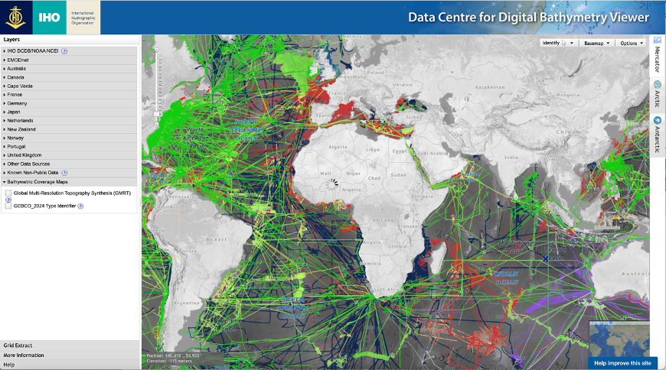

*Figure 4: Tracklines representing bathymetric data holdings in the IHO Data Centre for Digital Bathymetry data viewer.*

# **2. Transit Data Collection**

Transit mapping aims to maximize the value of vessel operations by systematically collecting high-quality bathymetric data during transits between mission sites or ports. Unlike dedicated surveys, transit mapping does not focus on specific study areas, but the principles of good data acquisition still apply. Collecting reliable multibeam echo sounder (MBES) data during transits requires appropriate systems, sensors, logging procedures, and minimal metadata capture. No data processing is required to make transit data valuable to the global mapping community.

## 2.1 Systems and Sensors

Modern bathymetric mapping relies on the integration of multiple sensors that together provide accurate depth and positioning information. In transit mapping, the systems described below are essential.

### **2.1.1 Multibeam Echo Sounders (MBES)**

Most research and exploration vessels are equipped with MBES systems capable of acquiring swath bathymetry and backscatter. These systems transmit acoustic pulses and record travel times across an array of beams, producing both depth and seafloor reflectivity. Even when vessels are transiting at higher speeds, MBES can produce valuable coverage.

Key considerations for MBES during transits:

* System should remain powered and logging throughout the transit.
* Beam footprint and spacing will vary with water depth and vessel speed.
* Roll, pitch, and yaw corrections are essential to minimize artifacts.
* Sound speed profiles are ideally collected in real-time, but can be applied during post-processing to save time and resources during transit operations.
* Backscatter data, while more variable in transit conditions, should also be logged.

### **2.1.2 Positioning and Motion Sensors**

Accurate positioning is critical to georeference MBES soundings:

* **GNSS (Global Navigation Satellite System):** Provides vessel position, time, and velocity. Modern receivers may integrate corrections (e.g., DGPS, RTK, PPP).
* **Inertial Motion Units (IMU):** Capture vessel heave, roll, pitch, and yaw, which must be applied to correct MBES data.
* **Gyrocompass / Heading Sensor:** Provides vessel heading, essential for aligning swath orientation with navigation data.

Transit mapping requires that positioning and motion sensors remain synchronized with MBES systems to ensure data quality. If the MBES is prepared and ready for operations aboard the vessel, no additional effort is required to leverage the system to acquire transit data.

### **2.1.3 Sound Speed Profiling**

Sound speed in the water column strongly affects MBES data quality. While regular deployment of sound velocity profilers (SVPs) or expendable probes (XBTs/XSVs) during transits is ideal for the correction for refraction errors, sound speed corrections can be applied during post-processing. Modeled sound speed profiles can also be applied to the MBES in real-time to better constrain refraction during data acquisition.

## **2.2 Sensor Configuration and Offsets**

Accurate bathymetric data requires precise knowledge of sensor positions relative to the vessel reference frame.

### **2.2.1 Sensor Offsets**

Offsets describe the distance between the vessel’s reference point and each sensor (MBES transducer, GNSS antenna, IMU). These should be measured in three axes (forward/aft, port/starboard, vertical) and documented in metadata. Inaccurate offsets can result in systematic errors in bathymetric data

### **2.2.2 Angular Offsets (Patch Test Calibration)**

Multibeam systems require calibration to account for angular misalignments between the MBES, IMU, and vessel reference frame. This is typically done through a patch test calibration during dedicated survey time. A routine patch test performed for survey operations is sufficient for transit mapping. No additional effort/calibration is required.

## **2.3 Ancillary Data**

While MBES bathymetry data are the primary focus for GEBCO, other data collected during transits can also enhance value:

* **Backscatter:** Provides seafloor characterization.
* **Water column data:** Can reveal gas plumes, biological layers, or other features.
* **Environmental sensors (e.g., CTD, thermosalinograph):** Provide supporting oceanographic context.

All ancillary datasets should be logged and included in data submissions when possible.

## **2.4 Software and Data Management**

### **2.4.1 Acquisition Software**

MBES manufacturers provide acquisition software (e.g., Kongsberg SIS, Simrad Seafloor Information System, Teledyne PDS). These systems log raw acoustic data, navigation, motion, and sound speed information. Logging should remain continuous for the duration of a transit.

### **2.4.2 Onboard Data Storage and Redundancy**

Transit mapping can generate large volumes of data. Data should be:

* Logged to shipboard servers with sufficient storage.
* Backed up to secondary drives or redundant systems.
* Organized by cruise or transit segment for easy contribution to public archives.

### **2.4.3 Data Transfer**

At the end of a voyage, data should be packaged and submitted to designated repositories. In some cases, subsets (e.g., quick-look grids) may be transmitted via satellite during the voyage, but bulk raw data transfer typically occurs upon return to port.

The IHO DCDB provides a data packaging and metadata gathering software tool ([CruisePack](https://www.ncei.noaa.gov/products/cruisepack)) that simplifies the collection and submission process for cruise-based data.

## **2.5 Best Practices for Transit Mapping**

* Keep MBES logging during all transits, even short ones.
* Deploy sound speed casts at regular intervals, especially when crossing major water masses.
* Record and maintain accurate metadata on system configuration, offsets, and draft.
* Maintain redundancy in data storage and power supply.
* At the end of each voyage, organize and archive raw and processed data for submission to repositories.
* Additional resources are available at [Multibeam Community Wiki](https://github.com/oceanmapping/community/wiki)

# 

# 

# **3. Data and Metadata**

Transit mapping can produce valuable bathymetric data, but the long-term usefulness of these data depends on the completeness and consistency of metadata. Metadata allows data users to evaluate quality, apply corrections, and integrate transit data with other datasets.

This chapter defines core metadata requirements for transit mapping, distinguishing between mandatory information (required for archiving and discovery) and recommended information which significantly improves downstream use (table 2).

*Table 2: Metadata definition (concept) compared with current GEBCO metadata field name and proposed GEBCO metadata field name. Modified from TSCOM Metadata Working Group 2024 Workshop Report.*

|  |  |  |
| --- | --- | --- |
| **Metadata Definition** | **Previous GEBCO metadata field** | **Revised GEBCO metadata field** |
| data_set_name | source_id | survey_id |
| Org where resource originated | source_org | survey_org |
| Country where resource originated | source_country | survey_country |
| Date created | source_date | survey_date |
| Device type (e.g. TID) |  | survey_device_type |
| Device Make/Model | source_device | survey_device |
| Platform Name | source_platform | survey_platform |
| Platform Type | source_platform_type | survey_plaform_type |
| Resource type:  - RawSurvey, ProcSurvey,  - SurveyProduct,  - CompositeProduct | dataset_proc_status | data_resource_type |
| Accessibility:  - direct download,  - on request,  - not accessible |  | data_accessibilty |
| Data license  - are there use restrictions?  - CC license? | dataset_restrictions | data_license |
| Landing page for learning more about data and/or downloading items. ( If dataDOI exists, use this with its url.) | source_URL | data_access_url |
| Data DOI | source_DOI | data_doi |
| Geometry for display/search | source_shapefile/geom | Geospatial geometry |

## **3.1 Data vs. Metadata**

* **Data**: The raw and processed MBES soundings, navigation, sound speed, and ancillary datasets collected during a vessel transit.
* **Metadata**: Descriptions that document how, when, and where the data were collected, what systems were used, how they were configured, and what processing steps were applied.

Transit mapping metadata should be captured at both the **cruise level** (voyage identifiers, vessel details) and the **system level** (MBES, GNSS, IMU, offsets, sound speed).

## **3.2 Importance of Metadata**

Most metadata necessary for the sharing and use of transit data are captured in the multibeam data files, and additional metadata are typically related to identifiers related to data acquisition such as vessel, voyage information, file format, device type, make and model. High-quality metadata enables the contribution and integration of transit mapping data into publicly accessible data archives. Metadata also enables attribution to data providers and important information for data consumers.

**3.3 Metadata and Data Formats**

Transit mapping data and metadata should follow community standards (e.g., ISO 19115, NetCDF/CF conventions, repository-specific formats). Repositories require a minimum set of metadata fields for transit mapping data to be accepted. Most descriptive metadata (e.g. dates, lat/long extent) can be extracted from the multibeam files and need not be provided as part of the data contribution. See the [IHO DCDB data contribution web page](https://www.ncei.noaa.gov/iho-data-centre-digital-bathymetry/submitting-marine-geophysical-data) for additional guidance and tools.

*Table 3. Minimal Metadata for Transit Mapping.*

|  |  |  |
| --- | --- | --- |
| **Field** | **Description** | **Example** |
| **ID** | Unique voyage or dataset identifier (assigned by operator or repository). | KN221-05 |
| **Vessel Name** | Name of vessel that collected the data. | Knorr |
| **Vessel Operator** | Institution or organization responsible for vessel. | Woods Hole Oceanographic Institution |
| **File Format(s)** | Format(s) of raw data submitted. | Kongsberg *.kmall |
| **Data License** | Licensing terms. | CC0 1.0 |
| **MBES System** | Make/model of multibeam echo sounder. | Kongsberg EM302 |

Metadata are as important as the data itself. Transit mapping data submitted without cruise identifiers, system configuration, and sound speed information may be of limited use to future users. Complete metadata ensures that data can be archived, reprocessed, and integrated into global mapping efforts.

# **4. Data Quality Assessment**

Transit mapping produces valuable swath bathymetry, but the quality of these data varies depending on vessel speed, environmental conditions, system calibration, and availability of supporting metadata. Unlike dedicated surveys, transits are not planned to optimize seafloor coverage or minimize artifacts, but with careful attention, transit data can achieve high value for science, mapping completeness, and integration into global compilations.

Data quality should be evaluated in terms of **fitness for purpose** rather than strict adherence to hydrographic survey standards such as IHO S-44. While transit mapping data often fall short of these survey benchmarks, they can still provide essential coverage in unmapped regions, enhance global bathymetric grids, and highlight priority areas for follow-on investigation. This approach has been emphasized in prior work (e.g., Ferrini et al., 2017; Ferrini et al., 2018 abstracts), which demonstrate that carefully documented and openly shared transit data can play a critical role in filling gaps and extending the reach of dedicated mapping campaigns. More recently, Hoy et al. (2024, *Marine Technology Society Journal*) further reinforced the importance of evaluating data in context, showing how fit-for-purpose transit mapping data can be integrated into larger compilations while still supporting a wide range of scientific and operational applications.

### **4.1 Data Consistency**

Consistency is a practical and widely applied way to assess the quality of transit mapping data:

* **Self-Consistency:** Compare overlapping swaths within the same transit, looking for offsets or mismatches at line crossings. Consistent data indicate stable system calibration and sound environmental conditions.
* **Peer-Consistency:** Compare transit data against existing multibeam surveys, charts, or global grids (e.g., GEBCO, GMRT). Peer-comparison is especially valuable for identifying systematic offsets that may result from navigation errors, draft changes, or uncorrected sound-speed variations. Ferrini et al. (2018, 2019) emphasized that such peer-comparisons are a critical step in determining readiness for integration into community compilations and ensuring that the data are reused appropriately.

Consistency assessments are often carried out during quick-look processing and provide useful diagnostics for inclusion in data quality reports. They can also help flag areas where additional attention may be required before the data are integrated into higher-order products.

### **4.2 Data Quality Assessment Reports**

Formal data quality assessment reports are not required for transit mapping data, but they can be highly useful when provided. The Rolling Deck to Repository (R2R) program has pioneered the development of [dashboards](https://www.rvdata.us/qa_info?vessel=string:All&cruise=&device=string:Multibeam%20Sonar) (Figure) and automated reports that summarize metadata completeness, sensor performance, and quick-look quality metrics. Such reports offer feedback to operators, improve transparency for users, and contribute to better understanding of data limitations.

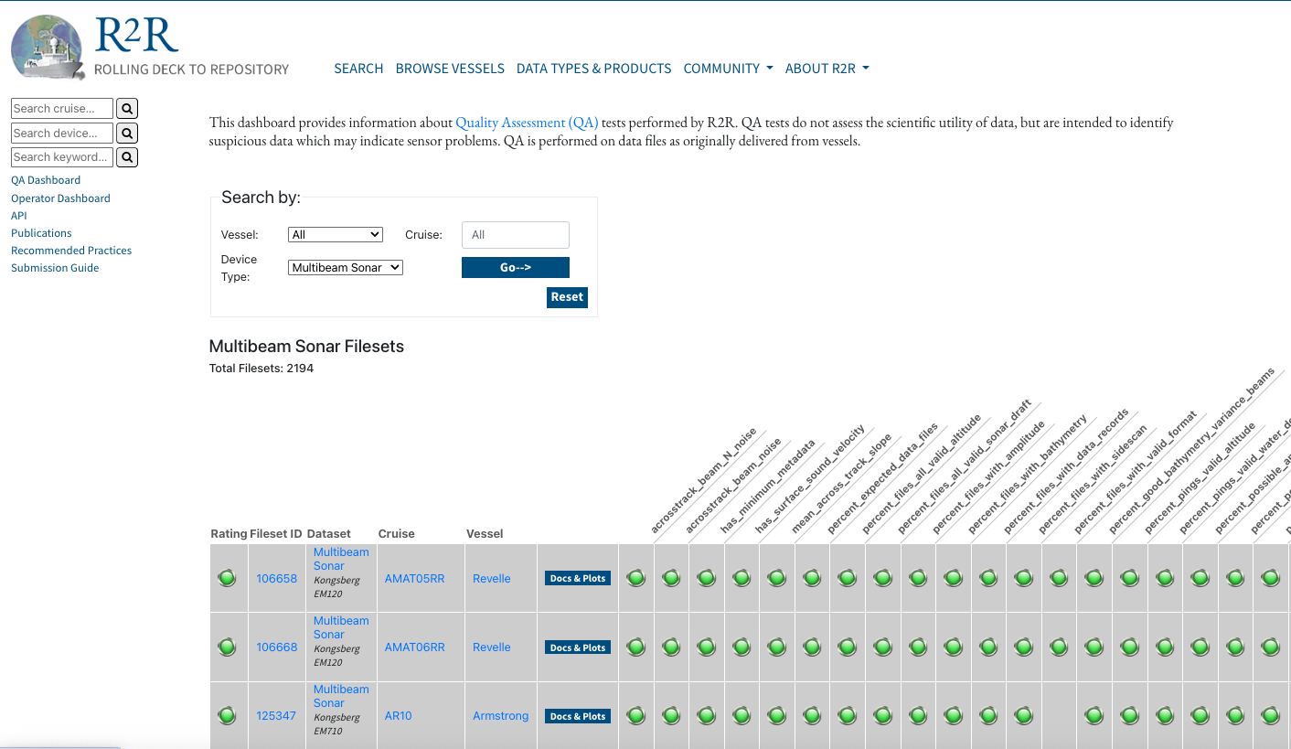

*Figure 5: Rolling Deck to Repository (R2R) program Quality Assessment (QA) dashboard for multiple multibeam datasets.*

### **4.3.4 Summary**

Transit mapping data vary in quality, but when properly documented, assessed, and shared, they represent a critical resource for advancing global seafloor mapping. The most effective way to evaluate such data is through the lens of **fitness for purpose**: rather than asking whether the data meet hydrographic survey standards (e.g., IHO S-44), the question becomes whether the data are suitable for integration into global grids, for guiding further exploration, or for filling gaps in poorly mapped regions.

Experience from community data systems demonstrates that even transit data of modest quality can be highly impactful when openly shared. Ferrini et al. (2017, 2018) highlighted the importance of comparing new datasets to pre-existing data (“peer comparison”) to identify offsets, evaluate consistency, and determine readiness for integration. GMRT practices (Drennon et al., OCEANS Conference) illustrate how large volumes of contributed data are reviewed for self- and peer-consistency, versioned, and curated with robust metadata before being released in global compilations. These community checks ensure transparency and reproducibility while preserving long-term scientific value.

Recent work by Hoy et al. (2024) further reinforces that opportunistic transit mapping can meaningfully support scientific research, navigation safety, and policy, even when the data are not survey-grade. By documenting uncertainty, assessing consistency, and sharing metadata, operators and repositories create pathways for the expert community to process, refine, and reuse the data for multiple applications.

In this context, all transit mapping data have value:

* **Uncertainty evaluation and consistency checks** increase transparency and facilitate integration.
* **Metadata completeness** ensures data can be interpreted and reprocessed in the future.
* **Community-based peer comparison** enables rapid identification of errors and enhances data readiness for reuse.
* **Quality assessment reports**, while optional, provide useful feedback loops that improve both acquisition practices and downstream applications.

Ultimately, the contribution of transit mapping is not measured by survey precision alone but by the collective knowledge it adds to global compilations. Every sounding helps close the gaps in our understanding of the seafloor. With appropriate documentation and open access, transit mapping data significantly expand bathymetric coverage, reduce knowledge gaps, and support a wide range of applications in research, navigation, and policy.

# **5 Enhancing the Value of Transit Mapping Through Planning**

Although vessel transits are not planned surveys, even modest forethought and operational adjustments can greatly enhance the value of the data collected. By incorporating transit mapping considerations into voyage planning and shipboard practices, operators can maximize the scientific and operational return from time at sea.

## 5.1 Vessel

* **Route Selection:** Where possible, transit routes can be optimized to pass through areas with little or no modern bathymetric coverage. Strategic adjustments of only a few nautical miles can transform an otherwise routine passage into a meaningful contribution to filling mapping gaps. Coordinating with existing compilations such as GEBCO or GMRT allows operators to identify priority corridors where new data would be most impactful. There are multiple tools that can be used to assist in route selection including web services made available through the [IHO DCDB Data Explorer](https://www.ncei.noaa.gov/maps/iho_dcdb/), [BathyGlobe](https://www.ccom.unh.edu/research/research-projects/bathymetric-globe) and [GeoMapApp](https://www.geomapapp.org/), as well as custom planning applications developed by communities around the world.
* **System Readiness:** Multibeam echo sounders (MBES) and associated sensors yield the most useful results when they are properly calibrated and consistently operated. Keeping MBES, navigation, and motion reference systems powered, logging, and regularly maintained during transits ensures that every opportunity to collect data is realized. Attention to system health and calibration reduces noise, offsets, and artifacts that can limit the usefulness of the data downstream.
* **Sound Speed Sampling:** Accurate water column information is essential for interpreting MBES data. Deploying sound velocity profilers (SVPs) or expendable probes, especially when crossing boundaries between distinct water masses, helps minimize refraction errors and improves the reliability of depth and backscatter measurements. Even occasional casts along a transit can significantly improve data quality in challenging environments.
* **Vessel Speed:** While transits are often conducted at higher cruising speeds, modest reductions in speed in regions of particular mapping importance can increase sounding density and improve data quality. Small slowdowns—applied selectively in poorly mapped corridors—can create disproportionately valuable datasets without significantly delaying arrival times.

Even small adjustments in planning, such as refining routes, maintaining system readiness, collecting sound speed data, or moderating speed in critical areas, can yield substantial gains in mapping coverage and quality. These practices do not transform a transit into a full hydrographic survey, but they do ensure that every mile steamed contributes as much as possible to global seafloor knowledge. In this way, vessel operators can align operational efficiency with the shared international goal of accelerating the completion of a global map of the ocean.

## 5.2 Institutional Policies to Support Transit Mapping

Institutions that operate vessels play a central role in normalizing transit mapping as part of routine shipboard practice. Establishing clear institutional policies ensures that the collection and submission of transit data are not treated as optional extras, but as a recognized and expected component of vessel operations. Such policies provide continuity across cruises, vessels, and staff, while also reinforcing the institution’s commitment to contributing to international ocean mapping efforts.

Key elements of effective institutional policies include:

* **Encouraging MBES Operations During Transits:** Multibeam echo sounders and associated sensors should remain powered and logging during all feasible transits. A clear expectation that mapping systems be active whenever possible maximizes data acquisition opportunities without interfering with the vessel’s primary mission.
* **Ensuring Metadata Completeness:** Even minimal metadata—such as cruise identifiers, vessel and instrument information, and basic acquisition parameters—are essential to make data discoverable and usable. Policies should set baseline requirements for metadata submission, ensuring that repositories and downstream users can interpret and process the data appropriately.
* **Leveraging Community Resources and Training:** Maintaining high-quality data collection depends on well-trained shipboard personnel. Institutions should support access to community training resources, workshops, and best-practice guidelines for technicians and operators. Sharing expertise across the fleet builds capacity and promotes consistency in data acquisition practices.
* **Facilitating Timely Submission of Data Packages:** Institutions should implement mechanisms to ensure that raw data packages and accompanying metadata are submitted to appropriate repositories as soon as possible after a voyage. Timely submission reduces the risk of data loss, accelerates availability, and allows the broader community to begin processing, validating, and reusing the data.

By codifying these practices into institutional policies, operators reinforce that transit mapping is an integral component of responsible vessel operation. Clear expectations, consistent training, and streamlined submission processes help embed transit mapping into the operational culture of research fleets, accelerating the flow of valuable data into the global commons and supporting the collective effort to map the world’s ocean floor.

## 5.3 User Awareness and Liability

Repositories and institutions make transit mapping data openly available, but always on a **user-beware basis**. Because these data are collected opportunistically during vessel transits rather than through dedicated hydrographic surveys, their quality and completeness can vary significantly. Users are therefore expected to exercise judgment in how they interpret and apply the data.

Key responsibilities of data users include:

* **Recognizing Uncertainty:** Users must carefully consider the uncertainty and limitations of transit mapping data, which may be influenced by vessel speed, environmental conditions, or incomplete metadata.
* **Avoiding Assumptions of Survey-Grade Quality:** Unless explicitly documented, transit data should not be assumed to meet hydrographic survey standards. Treating opportunistic data as equivalent to survey-grade data may lead to misinterpretation or misuse.
* **Applying Independent Quality Control:** For safety-critical applications—such as navigation, engineering design, or hazard mitigation—users must conduct their own quality control checks and confirm whether the data are fit for their intended purpose. Transit data may provide valuable context but are not a substitute for certified survey products in such applications.

Neither repositories nor vessel operators bear liability for the third-party use of transit mapping data. The responsibility rests with users to assess whether the data meet their requirements and to apply the necessary checks before reuse.

By clearly articulating these expectations, repositories promote transparency and ensure that transit mapping data can be shared openly while minimizing the risk of inappropriate application. This approach preserves the principle of open access while safeguarding both contributors and users, and it reinforces the broader ethos of fitness for purpose that underpins the responsible use of transit mapping data.

# **6. Additional Considerations**

Transit mapping is a powerful and cost-effective way to expand bathymetric coverage, but there are practical, legal, and policy issues that vessel operators and institutions should consider. This chapter highlights several additional considerations related to planning, licensing, access, and long-term use of transit mapping data.

## 6.1 Capacity Building and Community Benefits

Transit mapping contributes not only to advancing scientific knowledge, but also to building capacity and strengthening engagement across the global ocean community. Because it transforms routine vessel operations into opportunities for discovery, transit mapping is uniquely positioned to serve as both a scientific and an educational tool.

* **Training and Workforce Development:** Transit mapping provides valuable hands-on training for shipboard technicians, students, and early-career scientists. From system calibration and metadata management to quick-look processing and data submission, every step in the workflow offers learning opportunities that build technical skills and cultivate the next generation of ocean professionals. Embedding training into transit activities ensures that capacity building happens continuously, rather than only during major expeditions or dedicated campaigns.
* **Access for Underserved Communities:** By supplying openly available data, transit mapping helps communities and institutions with limited resources for dedicated surveys. Regions that may not have direct access to advanced mapping technology or research vessels still benefit from the global pool of data collected in transit. These contributions can support local research, education, hazard assessment, and sustainable resource management—enhancing the global equity of ocean knowledge.
* **International Cooperation and Shared Goals:** Because transit data are shared openly, they directly contribute to international initiatives such as Seabed 2030 and the UN Decade of Ocean Science for Sustainable Development. The practice of open submission and standardized reporting fosters collaboration across borders and sectors, ensuring that the benefits of transit mapping extend beyond individual institutions or nations.

By adopting open, standardized practices, transit mapping strengthens international cooperation and ensures that the knowledge gained from each vessel’s passage is shared broadly. In doing so, it supports a more inclusive, equitable, and globally connected ocean science community—one in which every contribution, large or small, helps accelerate progress toward mapping the entire seafloor.

## 6.2 Open Access and Licensing

Data collected during transits are typically made available under **open licenses**, most often the **Creative Commons Zero (CC0 1.0) universal public domain dedication**. This ensures that anyone may use, share, and build upon transit mapping data without restriction.

Key points:

* By submitting transit mapping data to repositories (e.g., IHO DCDB, PANGAEA, MGDS, R2R), data providers consent to open release of those data under CC0 1.0.
* Open licensing maximizes the scientific, educational, and societal benefits of data.
* Users must still evaluate data quality and suitability for their purpose (“user beware”), but licensing guarantees unrestricted access.

## 6.3 Operations in International Waters and EEZs

Transit mapping can be conducted in both international waters and within maritime zones subject to national jurisdiction, but the operational priorities differ.

* **International Waters as a Top Priority:** Because no permissions are required to record data in areas beyond national jurisdiction, international waters offer the most immediate and practical opportunity for expanding global bathymetric coverage. Transit mapping in these regions ensures that valuable data can be acquired and shared without delay, making a direct and unrestricted contribution to global compilations such as GEBCO. Prioritizing transit mapping in international waters accelerates progress toward a complete map of the seafloor while avoiding the complexities of jurisdictional clearance.
* **Opportunities Within EEZs:** At the same time, mapping within Exclusive Economic Zones (EEZs) holds enormous promise. EEZs often include large regions of seafloor that remain poorly mapped, despite their importance for national priorities such as hazard assessment, fisheries management, infrastructure development, and marine spatial planning. Where operators can obtain the necessary permits, transit mapping within EEZs provides a cost-effective means of advancing both national and global goals.
* **Respecting National Policies:** When transit mapping occurs within EEZs, operators must ensure that all necessary permits are obtained and that data collection complies with national laws and regulations. Data repositories play a key role in managing these datasets: restrictions or caveats on access should be documented clearly in metadata so that repositories can handle archiving and distribution appropriately.

Transit mapping in international waters should be promoted as a global top priority, given the absence of legal barriers and the urgency of improving coverage in the High Seas. However, with the appropriate permissions, EEZ transits also represent a significant opportunity to contribute to both national development and the global commons. Together, these complementary approaches maximize the impact of transit mapping and help ensure that every mile steamed contributes to the shared goal of mapping the world’s ocean floor.

## 6.4 Supplemental Resources

A variety of supplemental documents and references provide technical detail and examples of transit mapping practices. These include:

* Repository-specific submission guides (e.g., R2R, PANGAEA, MGDS).
* IHO guidance documents (e.g., C-13 Manual on Hydrography; S-44 Hydrographic Survey Standards).
* Best-practice guides from international projects such as Seabed 2030.

These resources are updated regularly, and stakeholders are encouraged to consult repository websites for the latest requirements.

# **7. Summary and Conclusions**

Transit mapping transforms otherwise unused vessel time into valuable seafloor mapping opportunities. By collecting multibeam and ancillary data during transits, operators can make significant contributions to global seafloor mapping while carrying out their primary missions.

By considering open licensing, national regulations, thoughtful planning, institutional policies, and user awareness, stakeholders can ensure that transit mapping data are widely usable and impactful. When combined across the global fleet, these contributions are a major driver toward achieving complete mapping of the seafloor, advancing scientific understanding, supporting safe navigation, and enabling sustainable use of ocean resources.

# **8. References**

***(references are not considered exhaustive and have not been fully mapped to text)***

Drennon, H.C.; Ferrini, V.L.; Morton, J. (2023). Multibeam Data Curation and Synthesis Through the Global Multi-Resolution Topography Synthesis (GMRT). *OCEANS 2023 - MTS/IEEE U.S. Gulf Coast*, Biloxi, MS, USA, 2023,. pp. 1-4, doi: 10.23919/OCEANS52994.2023.10337363.

Ferrini, V. *et al*., (2023). "Developing a Vision for Improving the Discovery and Accessibility of Bathymetric Data," *OCEANS 2023 - MTS/IEEE U.S. Gulf Coast*, Biloxi, MS, USA, 2023, pp. 1-4, doi: 10.23919/OCEANS52994.2023.10337031.

Ferrini, V., Morton, J.J.; Gee, L.; Heffron, E.; Drennon, H.; Raineault, N.; and Carbotte, S.M. (2020). Initial Efforts Toward Coordinated Community Data Processing to Accelerate the Growth of Publicly Available Bathymetric Data Products, AGU 2020 Fall Meeting, 01-17 December 2020, [doi: 10.1002/essoar.10505639.1](https://doi.org/10.1002/essoar.10505639.1).

Ferrini, V. and C. Peters (2022). ​​Ocean Exploration in a Data-Rich World. White Paper prepared for the 2022 National Ocean Exploration Forum. <https://col.ucar.edu/sites/default/files/2022-10/Ferrini-Peters_2022NOEF_Whitepaper_2-1-22.pdf>

Ferrini, V., Morton, J., Drennon, H., Uribe, R., Miller, E., Martin, T., Nitsche, F., Goodwillie, A., and Carbotte, S. (2022). Global Multi-Resolution Topography (GMRT) Synthesis – Tools and Workflows for Processing, Integrating and Accessing Multibeam Sonar Data, EGU General Assembly 2022, Vienna, Austria, 23–27 May 2022, EGU22-13349 (invited), <https://doi.org/10.5194/egusphere-egu22-13349>.

Ferrini, V.L.(2023). Transit Mapping in Support of the Global Ocean Mapping Community: We have the tools, do we have the will? 17th Kongsberg Forum for Exchange of Mutual Multibeam Experiences (FEMME). Edinburgh, Scotland, Sept 2023.

Hoy et al., (2025).

Seabed 2030 Project, (2025). Transit One pager for public distribution: <https://seabed2030.org/resources/?filter=documents>