
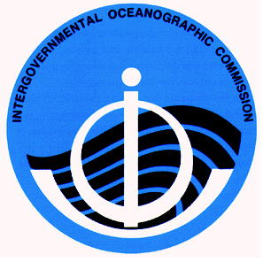
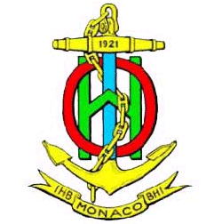
INTERGOVERNMENTAL OCEANOGRAPHIC
COMMISSION
COMMISSION OCEANOGRAPHIQUE
INTERGOUVERNEMENTALE
PARIS
INTERNATIONAL HYDROGRAPHIC
ORGANIZATION
ORGANISATION HYDROGRAPHIQUE
INTERNATIONALE
MONACO

C E N T E N A R Y 1 9 0 3 – 2 0 0 3

Call for Papers
Fifth Annual
GEBCO Bathymetric Science Day
Callao, Peru
15 September 2010
Hosted by the Peruvian Directorate of Hydrography and Navigation

The IHO/IOC Committee for the General Bathymetric Charts of the Oceans (GEBCO, www.gebco.net) is the international body responsible for global bathymetric mapping and the naming of undersea features. GEBCO’s Technical Sub-Committee on Ocean Mapping (TSCOM) conducts research, reviews technical challenges and opportunities, maintains and improves the GEBCO Digital Atlas and global bathymetric grid, and advises GEBCO on scientific and technical aspects of its mission. The 26th meeting of the TSCOM will take place during 11 – 18 September 2010 hosted by the Directorate of Hydrography and Navigation in Callao and Lima, Peru. GEBCO’s Fifth Annual “Bathymetric Science Day” will be held on 15 September. Contributed papers on any topic related to ocean mapping and its applications are welcome. Focus areas include, but are not limited to:

- Uses of Google Ocean in research, education and outreach.
- Data management and exchange (web-enabled and geospatial-enabled services, metadata standards, database schema, data processing and validation, etc.).
- Merging topography, bathymetry, and shoreline data in the coastal zone (seamless models, vertical datum issues, etc.).
- Compilation and fusion of heterogeneous data (single and multi-beam, points, grids, shorelines, etc.)
- Applications and application-driven mapping (e.g., bathymetric needs of fisheries and habitat sciences, hydrodynamic models, etc.)
- Interpolation and gap-filling schemes for incompletely surveyed areas.
- Modeling bathymetric uncertainty.

All contributions will be featured on the Agenda, in the Minutes, and on www.gebco.net. TSCOM is an excellent venue for exchanging ideas and growing new collaborations. Please come, share your knowledge, and join an international and cross-disciplinary team engaged in exciting and fundamental work. The ocean is big and there is room for everyone to contribute. The TSCOM meeting is open, and any contributor to Science Day may attend all of TSCOM.

Those wishing to contribute a presentation should contact the TSCOM Chair and local coordinating committee by email to walter.hf.smith@noaa.gov, hmontoro@dhn.mil.pe, and lcano@dhn.mil.pe . Please include the anticipated Title of the contribution, the Authors and their Institutional Affiliations, and whether an oral or poster presentation is preferred. It is anticipated that, at some time closer to the meeting, a web site will be established to which contributors shall upload presentations and abstracts for the meeting program and minutes.

